Project ARGUS Class Diagram

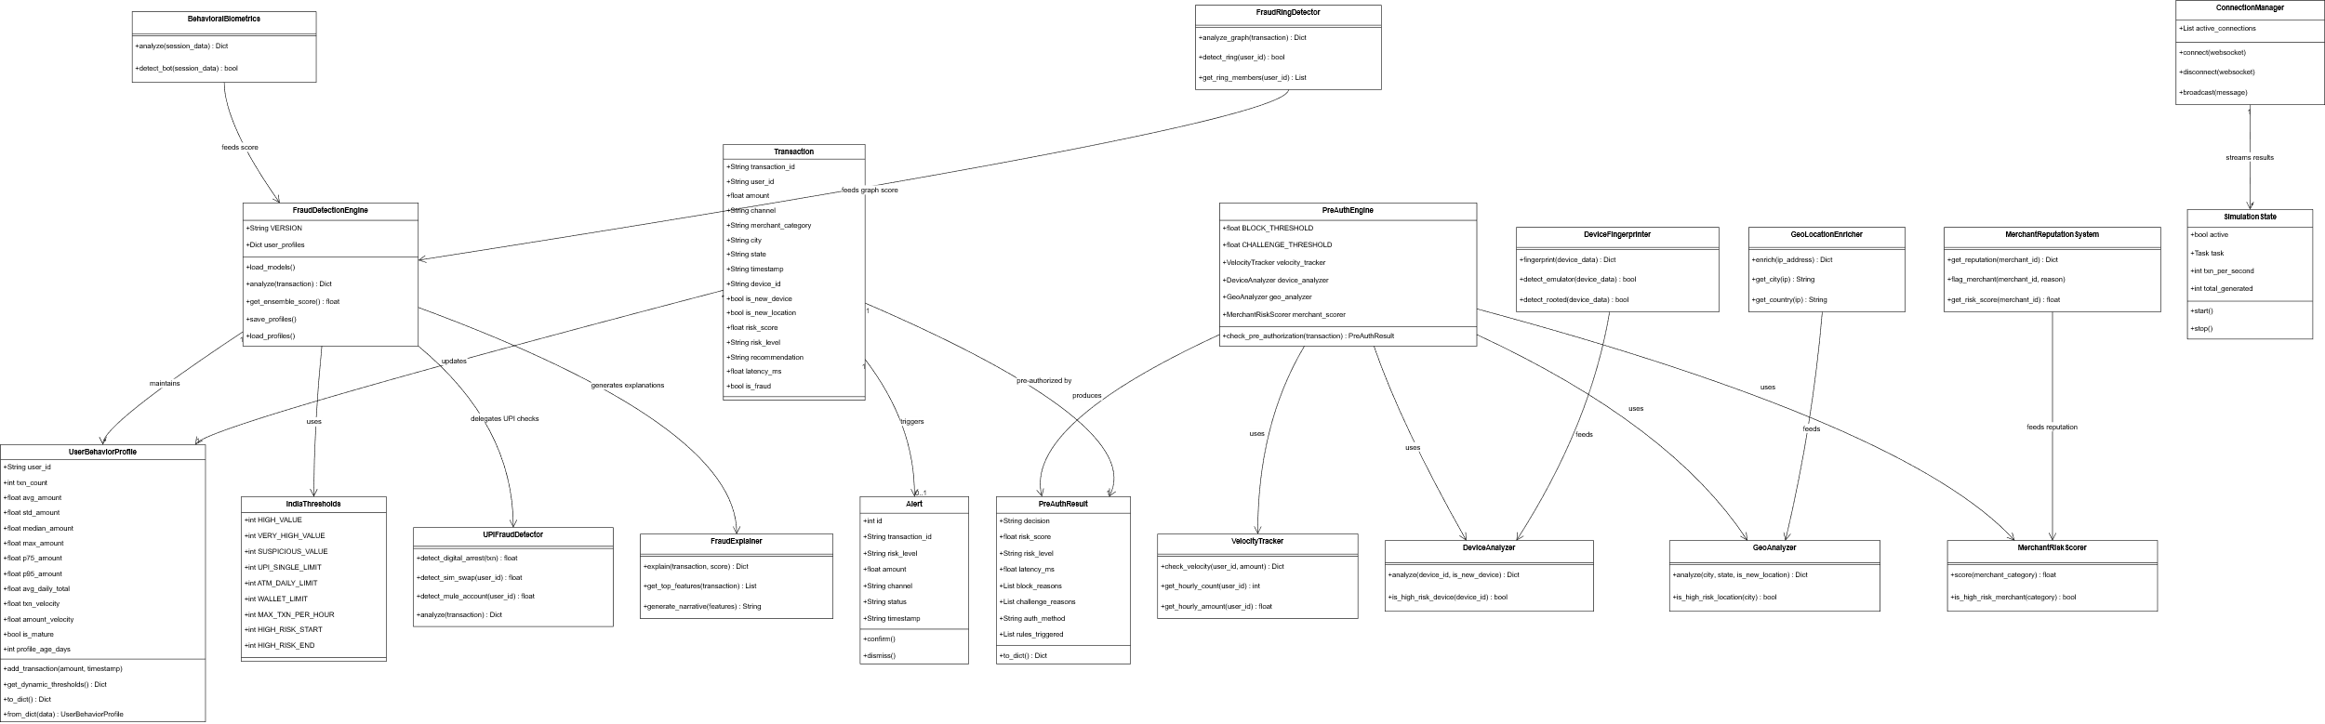

The class diagram for Project ARGUS models the structural design of the fraud detection system and illustrates how transaction data flows through multiple analytical components to detect suspicious activity. The architecture is centered around the FraudDetectionEngine, which aggregates behavioral, device, geographic, and transactional signals to compute a unified fraud risk score. Supporting modules perform specialized analysis such as velocity tracking, merchant risk evaluation, device fingerprinting, and graph-based fraud ring detection. Together, these components enable real-time fraud assessment, alert generation, and explainable decision-making within the system.

Total number of classes: 20
Classes included:
- Transaction
- Alert
- UserBehaviorProfile
- IndiaThresholds
- FraudDetectionEngine
- PreAuthEngine
- PreAuthResult
- VelocityTracker
- DeviceAnalyzer
- GeoAnalyzer
- MerchantRiskScorer
- DeviceFingerprinter
- GeoLocationEnricher
- BehavioralBiometrics
- FraudRingDetector
- MerchantReputationSystem
- UPIFraudDetector
- FraudExplainer
- ConnectionManager
- SimulationState
- Transaction: Represents a financial transaction processed by the system, containing contextual attributes such as amount, device, location, and timestamp. It acts as the primary data entity analyzed throughout the fraud detection pipeline.

- Alert: Represents a fraud alert generated for transactions flagged as suspicious. It records the risk level, transaction details, and alert status, and supports confirmation or dismissal during review.

- UserBehaviorProfile: Maintains statistical summaries of a user’s historical transaction activity, enabling the system to detect deviations from normal spending patterns and behavioral anomalies.

- IndiaThresholds: Defines configurable financial thresholds and regulatory limits relevant to the Indian digital payment ecosystem, which are used during transaction risk evaluation.

- FraudDetectionEngine: The central orchestration component that aggregates signals from multiple detection modules to compute a final fraud risk score and coordinate the system’s fraud analysis workflow.

- PreAuthEngine: Performs real-time risk checks before transaction authorization by evaluating device behavior, transaction velocity, geographic patterns, and merchant risk.

- PreAuthResult: Encapsulates the outcome of the pre-authorization analysis, including risk score, decision outcome, triggered rules, and latency.

- VelocityTracker: Monitors transaction frequency and cumulative spending within defined time windows to identify abnormal spikes in activity.

- DeviceAnalyzer: Evaluates device characteristics to detect unfamiliar or potentially compromised devices associated with a transaction.

- GeoAnalyzer: Analyzes geographic attributes of transactions to detect location anomalies relative to typical user activity.

- MerchantRiskScorer: Assigns risk scores to merchant categories based on historical fraud trends and transaction patterns.

- DeviceFingerprinter: Generates unique device fingerprints and detects suspicious device environments such as emulators or rooted devices.

- GeoLocationEnricher: Enhances IP-based location data to provide accurate geographic context for transaction analysis.

- BehavioralBiometrics: Analyzes user interaction patterns to distinguish legitimate human behavior from automated or bot-driven activity.

- FraudRingDetector: Performs graph-based analysis to identify coordinated fraud networks and linked suspicious accounts.

- MerchantReputationSystem: Maintains reputation scores for merchants and flags merchants associated with repeated fraudulent activity.

- UPIFraudDetector: Implements specialized detection logic for fraud patterns specific to UPI-based digital payment transactions.

- FraudExplainer: Generates interpretable explanations for fraud detection outcomes by identifying key features influencing risk scores.

- ConnectionManager: Manages real-time communication channels used for monitoring transactions and broadcasting system events.

- SimulationState: Controls system simulation processes used to generate synthetic transactions for testing and performance evaluation.

